Hi I will Teach you to hack any phone by using Termux app so let's get started. So the first tool I am going to teach you is (WishFish Tool). So by this tool you can hack any victim’s front camera by sending a link, it’s cool and easy.

So the first step is to type

1 $ apt update && apt upgrade

3 $ pkg install php

4 $ pkg install openssh

5 $ git clone <https://github.com/kinghacker0/WishFish>

6 $ cd WishFish

7 $ bash wishfish.sh

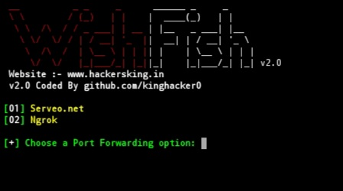☆so now you can see like this screen

☆Now simply Turn on your Hotspot.

☆After turning on your Hotspot choose option-2 (Ngrok)

☆Now you will see there is a link generated.Now simply send this link to Victim, when the victim open this link, in your Termux you will see that (Cam file received)

☆After that open your phone’s gallery, and then you will see the captured images by the victims Phone

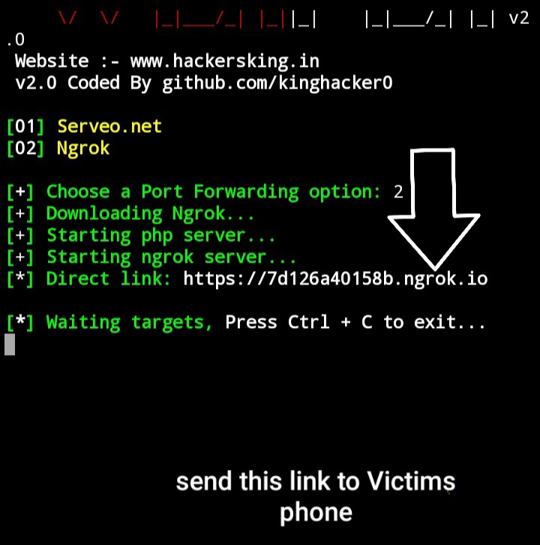

☆When he opens the link it will look like this



